**Laboratory 5 – OSPF Single Area Configuration**

Student name: Phan Phương Duy Student ID: ITITIU16010

**Topology**

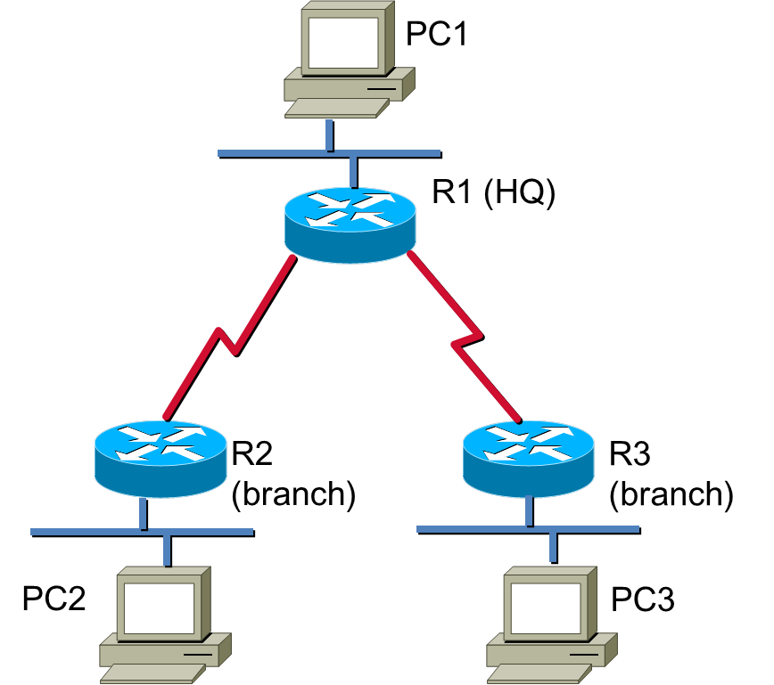

**IP Addressing**

Given the range 172.ID.0.0/16, please assign IP addresses for the above network.

LAN 1 has 2000 IPs, LAN 2 or LAN 3 has 1000 IPs each LAN.

|  |  |  |  |  |
| --- | --- | --- | --- | --- |
| **Device** | **Interface** | **IP Address** | **Subnet Mask** | **Default Gateway** |
| R1 | Fa0 | 192.168.1.1 | 255.255.255.192 |  |
| S0 | 192.168.1.194 | 255.255.255.224 |  |
| S1 | 192.168.1.226 | 255.255.255.224 |  |
| R2 | Fa0 | 192.168.1.65 | 255.255.255.192 |  |
| S0 | 192.168.1.193 | 255.255.255.224 |  |
| R3 | Fa0 | 192.168.1.129 | 255.255.255.192 |  |
| S0 | 192.168.1.225 | 255.255.255.224 |  |
| PC1 | NIC | 192.168.1.2 | 255.255.255.192 | 192.168.1.1 |
| PC2 | NIC | 192.168.1.66 | 255.255.255.192 | 192.168.1.65 |
| PC3 | NIC | 192.168.1.130 | 255.255.255.192 | 192.168.1.129 |

**Learning Objectives**

Upon completion of this lab, you will be able to:

* Perform basic configuration tasks on a router
* Configure and activate interfaces
* Configure OSPF routing on all routers
* Configure OSPF router IDs
* Verify OSPF routing using show commands
* Configure a static default route
* Propagate default route to OSPF neighbors
* Configure OSPF Hello and Dead Timers
* Document the OSPF configuration

**Scenarios**

In this lab activity, there are two separate scenarios. In the first scenario, you will learn how to configure the routing protocol OSPF using the network shown in the Topology Diagram in Scenario A. The segments of the network have been subnetted using VLSM. OSPF is a classless routing protocol that can be used to provide subnet mask information in the routing updates. This will al ow VLSM subnet information to be propagated throughout the network. In the second scenario, you will learn to configure OSPF on a multi-access network. You wil also learn to use the OSPF election process to determine the designated router (DR), backup designated router (BDR), and DRother states.

**Task 1: Perform Basic Router Configurations.**

**Clear any existing configurations on the routers** and perform basic configuration of the R1 and R2 routers according to the following guidelines:

1. Configure the router hostname.
2. Disable DNS lookup.
3. Configure a privileged EXEC mode password.
4. Configure a message-of-the-day banner.
5. Configure a password for console connections.
6. Configure a password for VTY connections.

**Task 2: Configure and Activate Serial and Ethernet Addresses.**

**Step 1: Configure interfaces on routers.**

Configure the interfaces on the routers with the IP addresses from the table under the Topology Diagram.

**Step 2: Verify IP addressing and interfaces.**

Use the **show ip interface brief** command to verify that the IP addressing is correct and that the interfaces are active. When you have finished, be sure to save the running configuration to the NVRAM of the router.

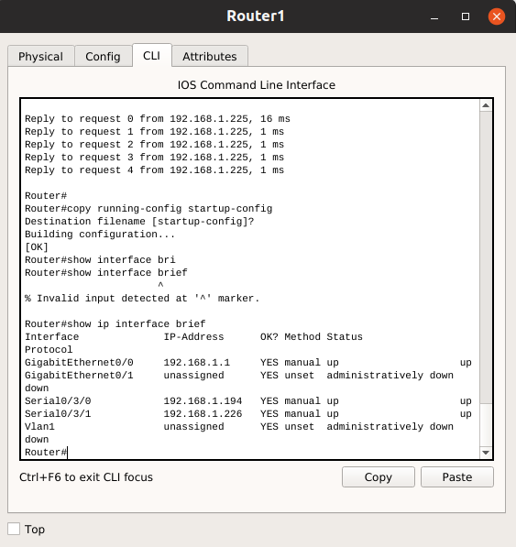

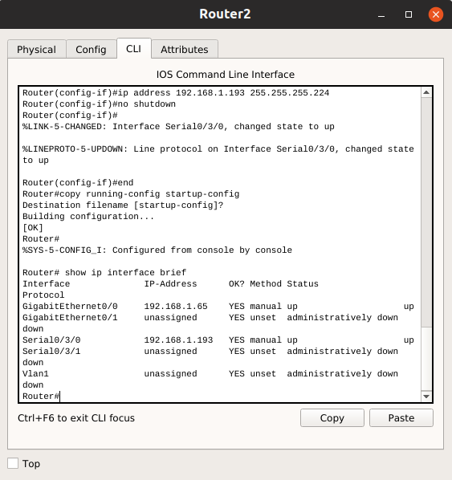

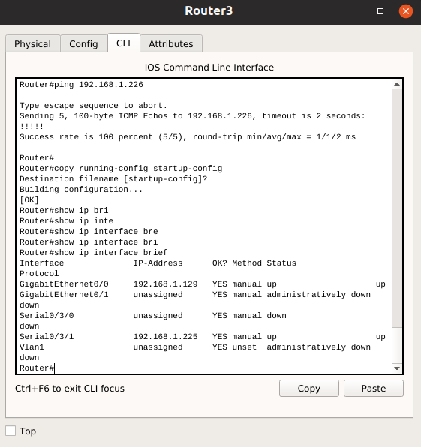

**Step 3: Configure Ethernet interfaces of PCs.**

Configure the Ethernet interfaces of PCs with the IP addresses and default gateways from the table under the Topology Diagram.

Test the PC configuration by pinging the default gateway from the PC.

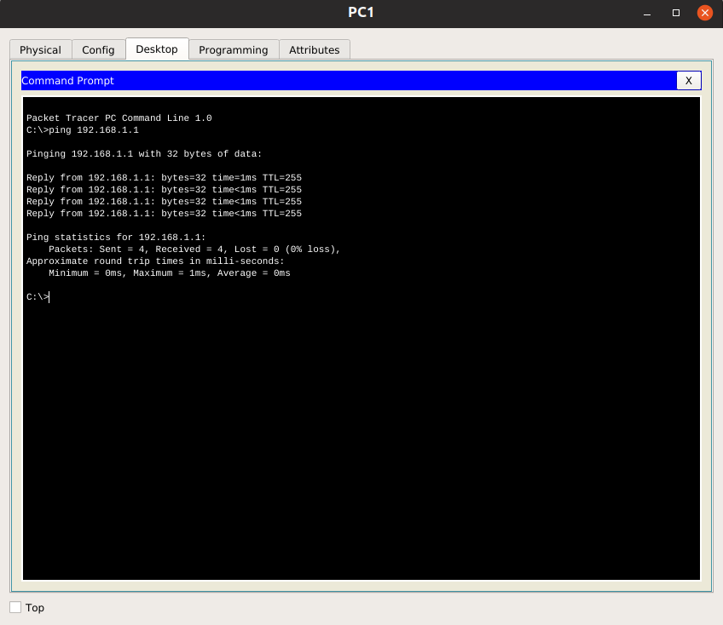

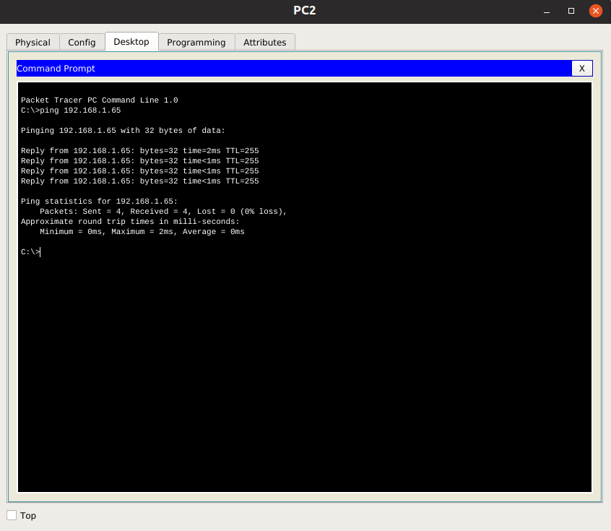

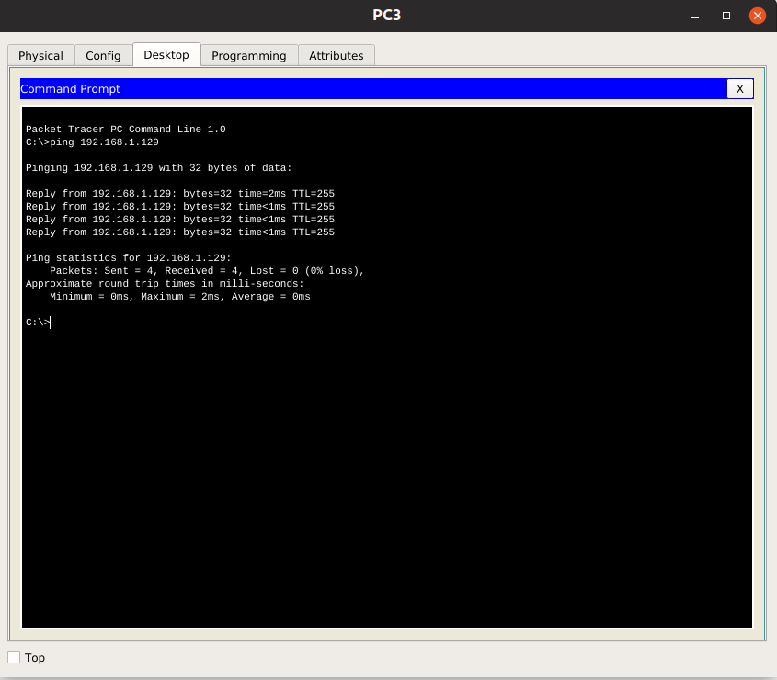

**Task 3: Configure OSPF on the R1 Router**

**Step 1: Use the router ospf command in global configuration mode to enable OSPF on the R1 router.**

Enter a process ID of 1 for the *process-ID* parameter.

R1(config)#**router ospf 1**   
R1(config-router)#

**Step 2: Configure the network statement for the LAN network.**

Once you are in the Router OSPF configuration sub-mode, configure the LAN1 network to be included in the OSPF updates that are sent out of R1.

R1(config-router)#**network <address> <wildcard-mask> area 0**   
Please explain above command

Network command allows us to specify the interfaces which we want to include in OSPF process. Address is the network ip address we want to advertise and wildcard mask are used with network ID to filter the interfaces. Wildcard mask are complement of subnet mask.

A classless routing protocol such as OSPF goes beyond the default boundary of mask and work well with Subnetted networks. With wildcard mask we can easily filter Subnetted networks.

Use an area ID of 0 for the OSPF *area-id* parameter. 0 will be used for the OSPF area ID in all of the **network** statements in this topology.

**Step 3: Similarly, configure the router to advertise the network attached to the Serial0 interface.**

**Task 4: Configure OSPF on the R2 and R3 Routers**

**Step 1: Enable OSPF routing on the R2 router using the router ospf command using process id 1.**

router ospf 1

**Step 2: Configure the router to advertise the LAN2 network in the OSPF updates.**

network 192.168.1.64 0.0.0.63 area 0

**Step 3: Configure the router to advertise the network attached to the Serial0 interface.**

network 192.168.1.192 0.0.0.31 area 0

Notice that when the network for the serial link from R1 to R2 is added to the OSPF configuration, the router sends a notification message to the console stating that a neighbor relationship with another OSPF router has been established.

**Step 4: Repeat from step 1 of this task for R3.**

**Task 5: Verify OSPF Operation**

**Step 1: On the R1 router, Use the show ip ospf neighbor command to view the information about the OSPF neighbor routers R2 and R3.**

You should be able to see the neighbor ID and IP address of each adjacent router, and the interface that R1 uses to reach that OSPF neighbor. Please highlight the output.

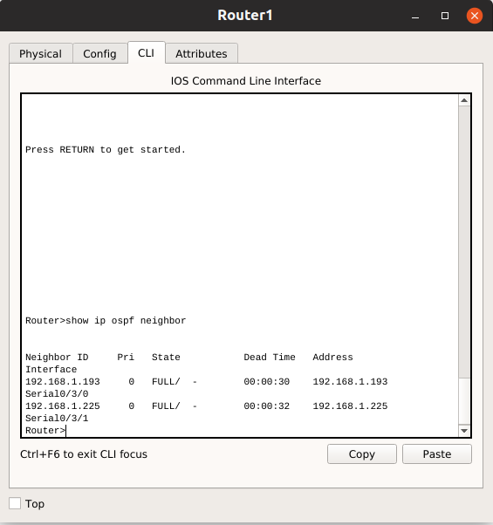

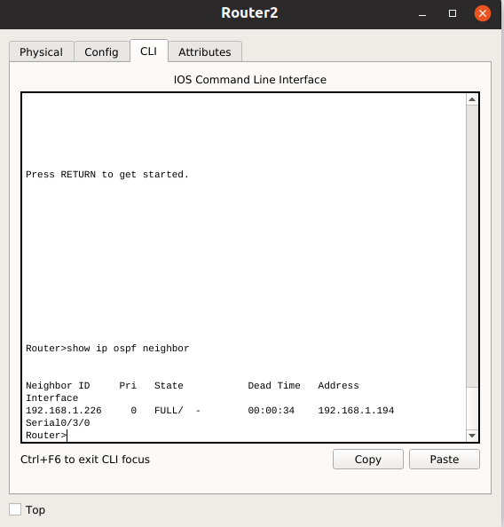

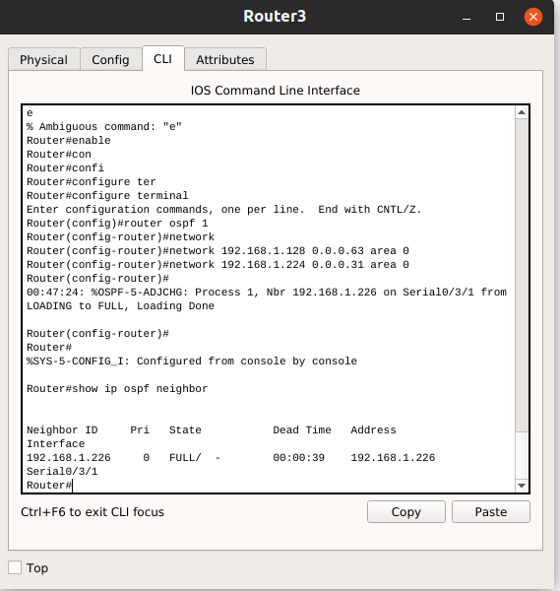

**Step 2: On the R1 router, use the show ip protocols command to view information about the routing protocol operation.**

Notice that the information that was configured in the previous Tasks, such as protocol, process ID, neighbor ID, and networks, is shown in the output. The IP addresses of the adjacent neighbors are also shown.

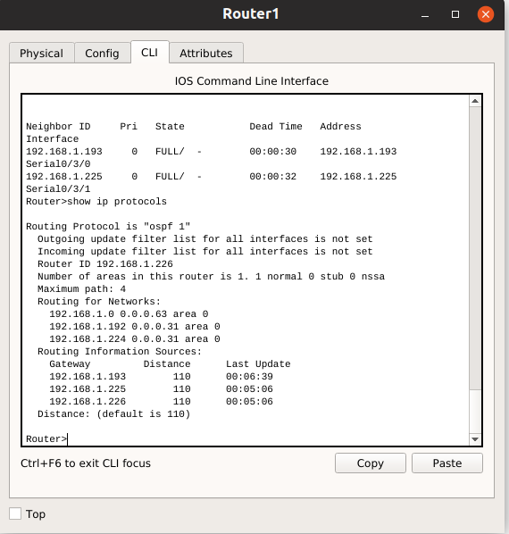

Notice that the output specifies the process ID used by OSPF. Remember, the process ID must be the same on al routers for OSPF to establish neighbor adjacencies and share routing information.

**Task 6: Examine OSPF Routes in the Routing Tables**

View the routing table on the R1 router. OSPF routes are denoted in the routing table with an "O".

R1#**show ip route**

Highlight the OSPF routes and explain the entries in details.

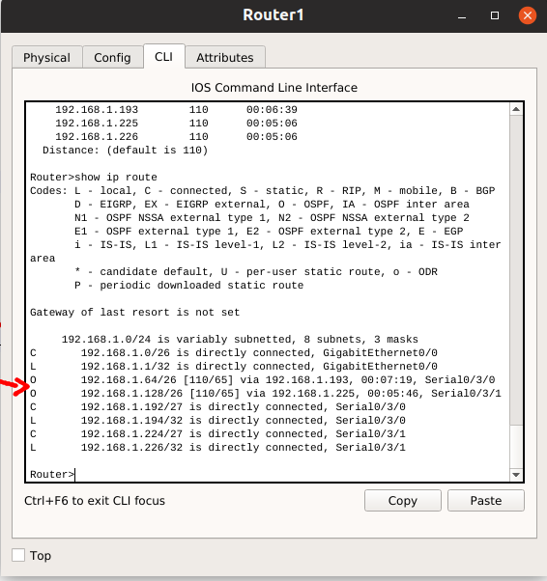

Notice that unlike RIPv2 and EIGRP, OSPF does not automatically summarize at major network boundaries.

**Task 7: Configure OSPF Cost**

**Step 1: Use the show ip route command on the R1 router to view the OSPF cost to reach the LAN2 and LAN3 networks.**

R1#**show ip route**

Paste the output here.



What is the OSPF cost to reach the above network?.

**Step 2: Use the show interfaces serial0 command on the R1 router to view the bandwidth of the Serial0 interface.**

R1#**show interfaces serial0**

Paste your output here.

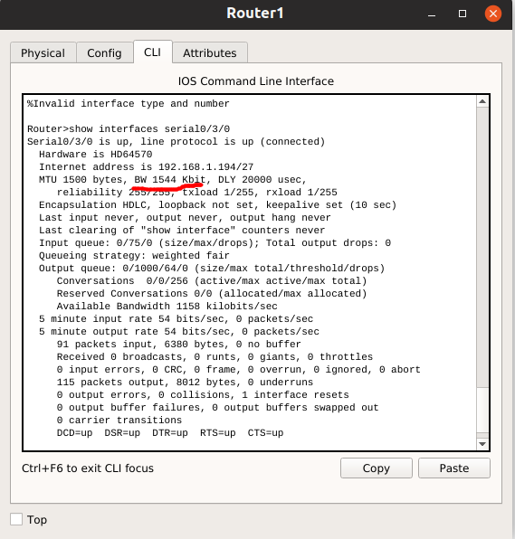

What is the bandwith of the interface ?

Bandwidth : 1544 Kbit

On most serial links, the bandwidth metric wil default to 1544 Kbits. If this is not the actual bandwidth of the serial link, the bandwidth will need to be changed so that the OSPF cost can be calculated correctly.

**Step 3: Use the bandwidth command to change the bandwidth of the serial interfaces of the R1 router to the actual bandwidth, 64 kbps.**

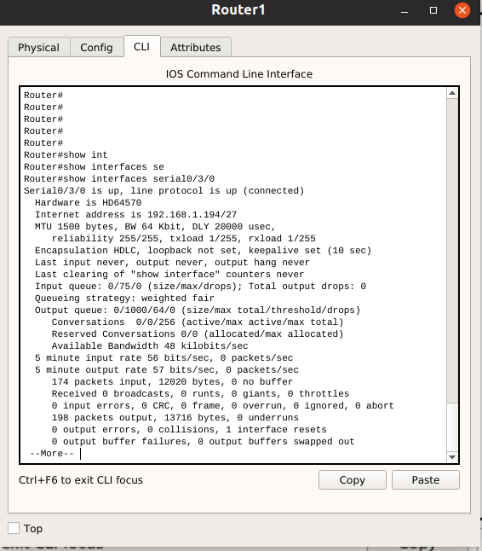

**Step 4: Use the show ip ospf interface command on the R1 router to verify the cost of the serial links.**

The result of the calculation: 108/64,000 bps = 1562.5

R1#**show ip ospf interface**   
  
Paste your output here.

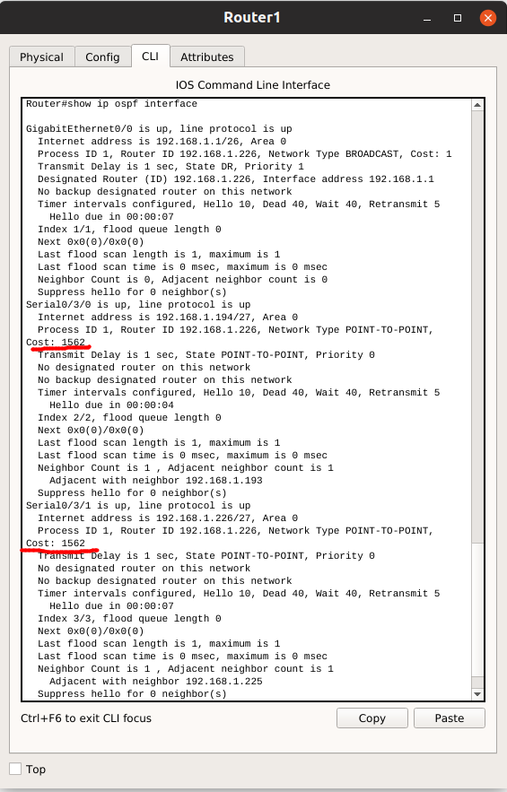

Now, what is the cost of the serial link?

Cost = 1562

Compare it with the result of the calculation: 108/64,000 bps.

The two results have the same value = 1562

**Step 5: Use the ip ospf cost command to configure the OSPF cost on the R2 router.**

An alternative method to using the bandwidth command is to use the ip ospf cost command, which allows you to directly configure the cost. Use the ip ospf cost command to change the bandwidth of the serial interfaces of the R2 router to 1562.

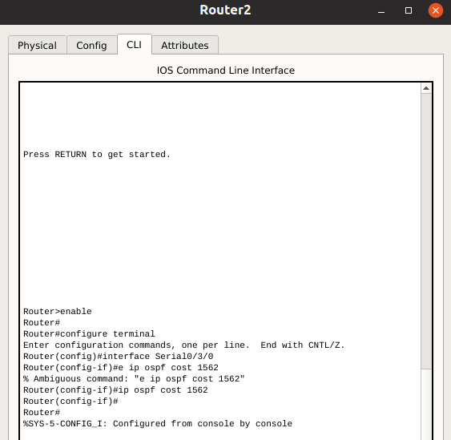

**Step 6: Use the show ip ospf interface command on the R2 router to verify that the cost of the link the cost of each of the Serial links is now 1562.**

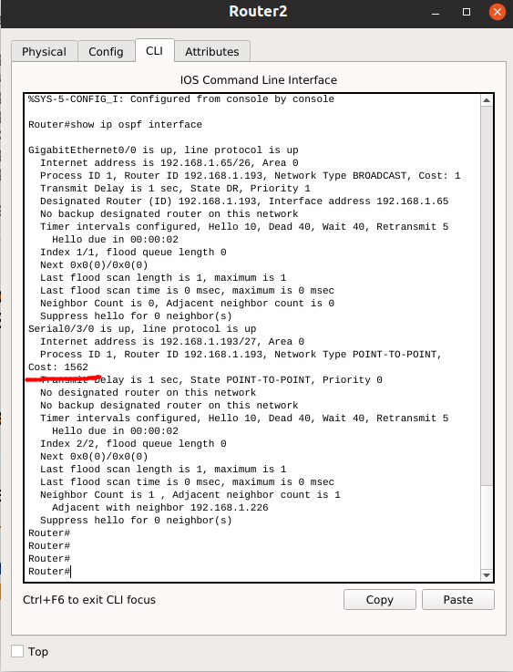

**Task 8: Redistribute an OSPF Default Route**

**Step 1: Configure a loopback address on the R1 router to simulate a link to an ISP.**

**Step 2: Configure a static default route on the R1 router.**

Use the loopback address that has been configured to simulate a link to an ISP as the exit interface.

**Step 3: Use the default-information originate command to include the static route in the OSPF updates that are sent from the R1 router.**

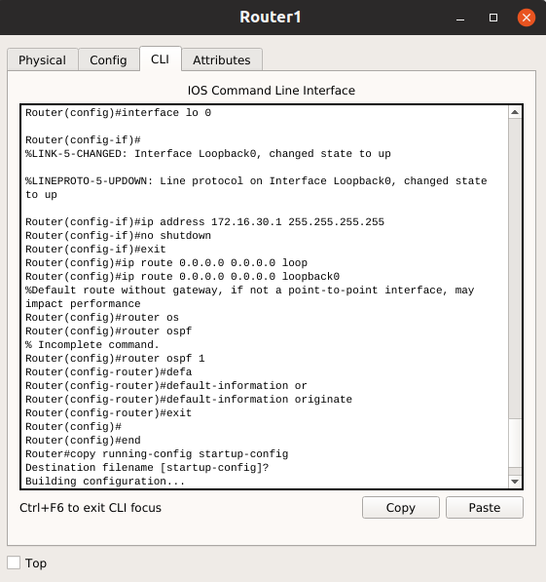

Result :From PC3, we can ping to the ISP

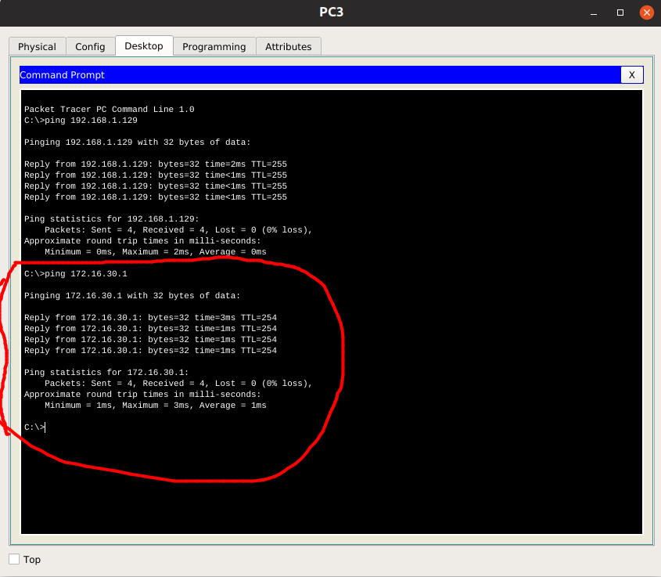

**Step 4: View the routing table on the R2 and R3 routers to verify that the static default route is being redistributed via OSPF. Please explain the output in details:**

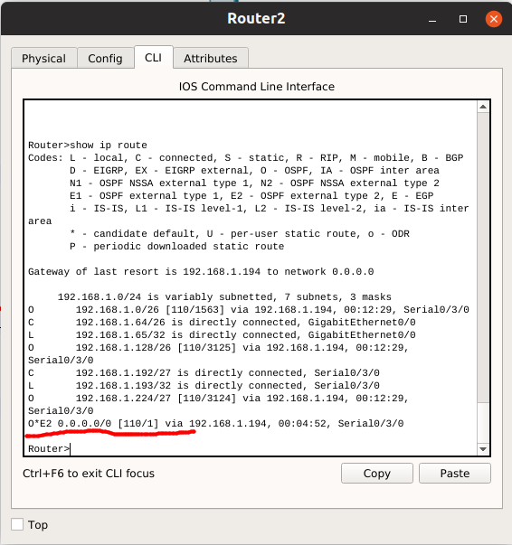

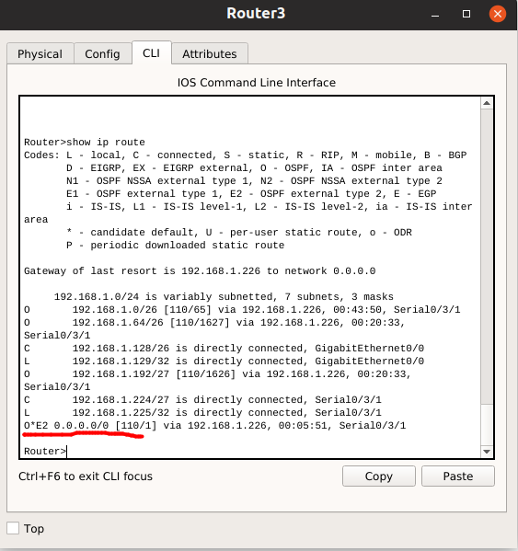

**Task 9: Document the Router Configurations.**

On both router, capture the following command output to a text file and attach to your report:

* Running configuration
* Routing table
* Interface summarization
* Output from **show ip protocols**

**END.**